# IsDB LEGS NAKASEKE - PHOTOS SHOWING COMPLETED ROAD VS PREVIOUS CONDITION

**SWAMPY CONDITIONS**

**DURING CLEARANCE VS FINISHED.SECTION AT (KM 1+600-2+200) ON GOMERO- MIGANI-KAGONGI ROAD**

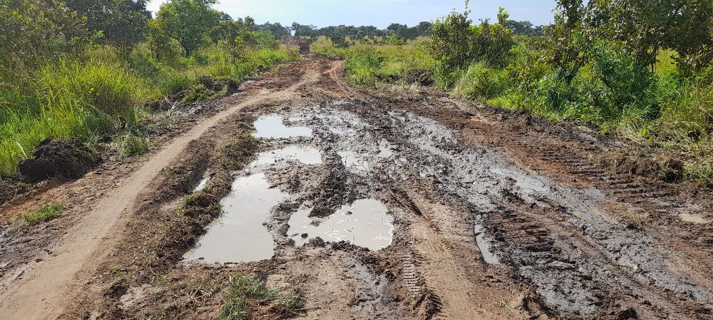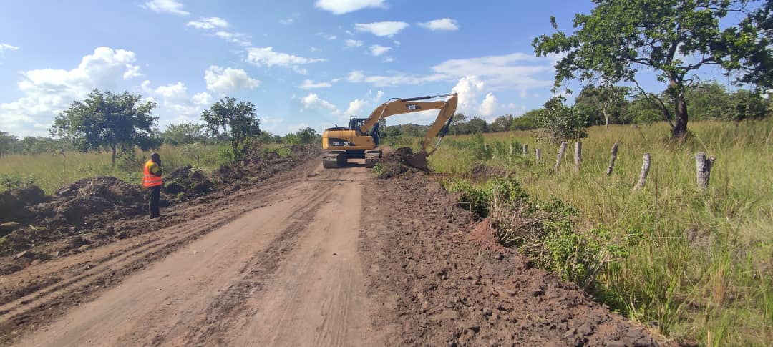

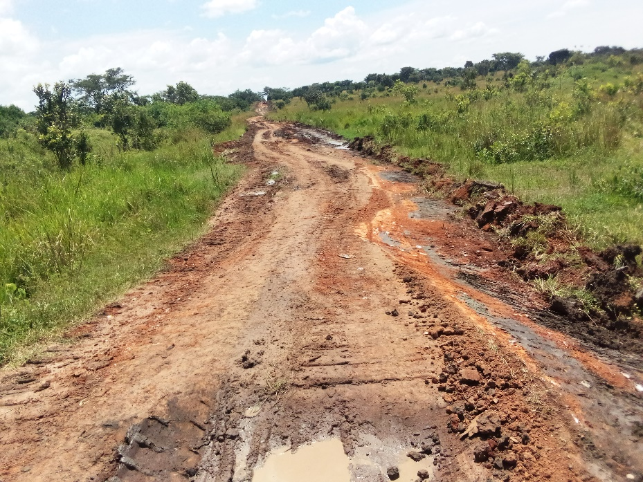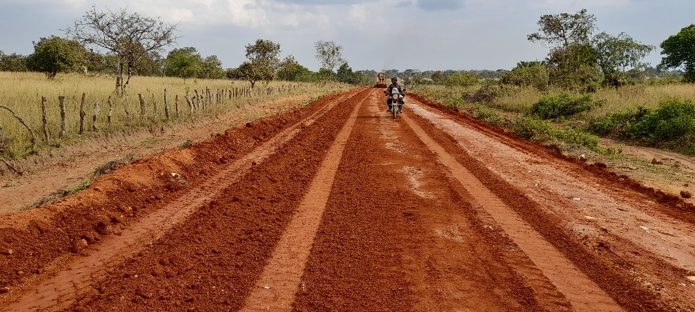

**SWAMPY CONDITIONS**

**DURING CLEARANCE VS FINISHED.SECTION AT (KM 4+130-4+730) ON GOMERO- MIGANI-KAGONGI ROAD** 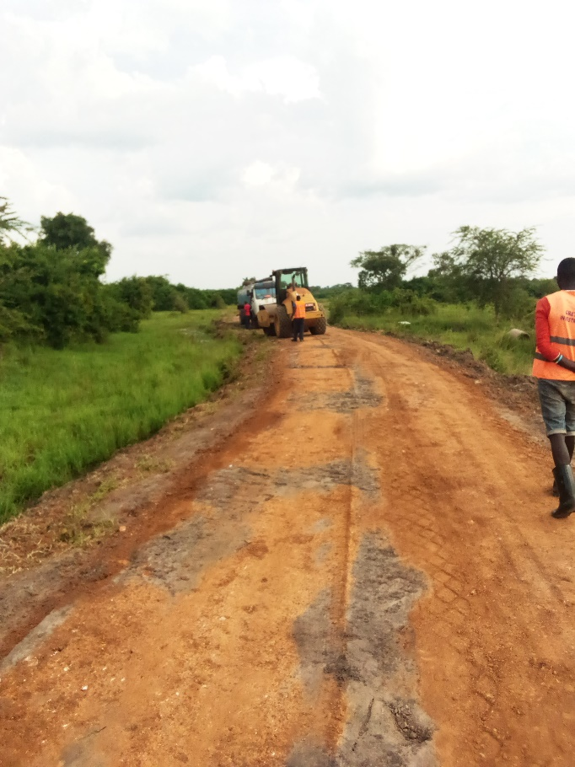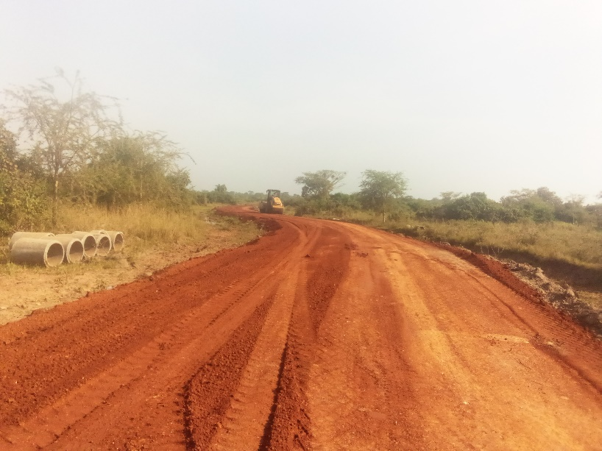

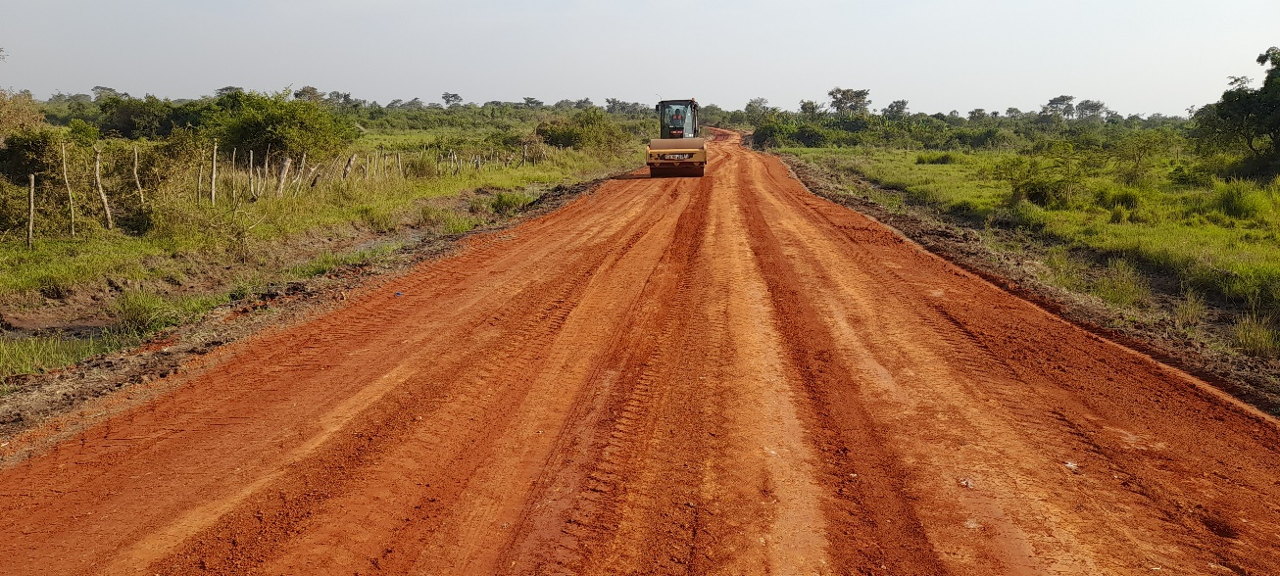

**SWAMPY CONDITIONS**

**DURING CLEARANCE VS FINISHED.SECTION AT (KM 9+500-10+000) ON GOMERO- MIGANI-KAGONGI ROAD 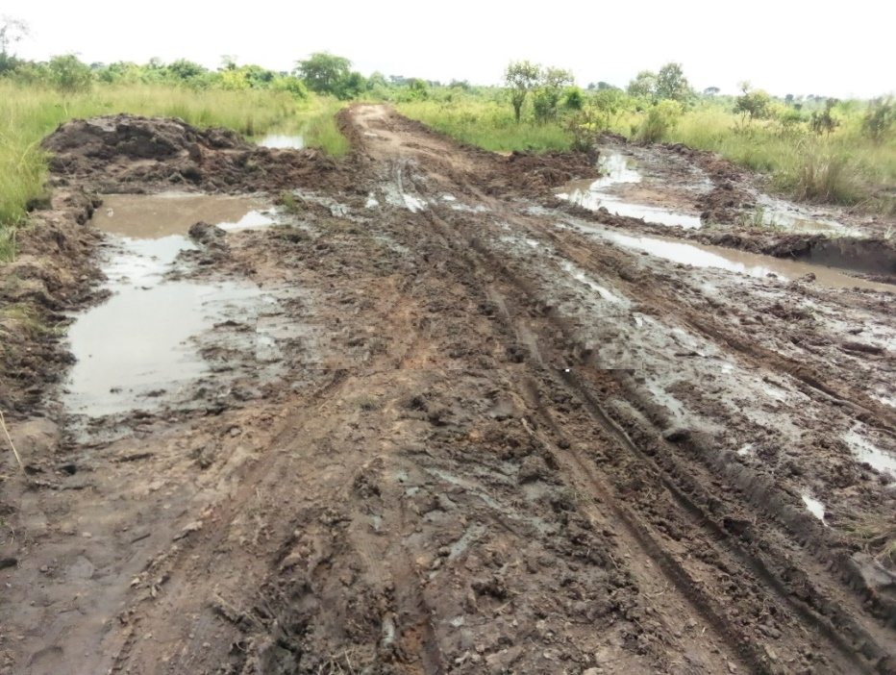**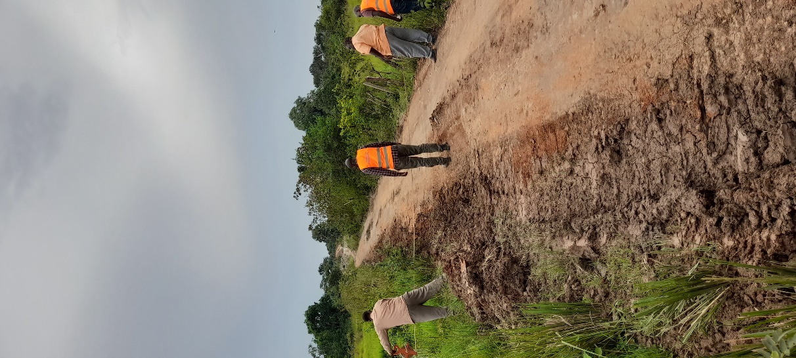

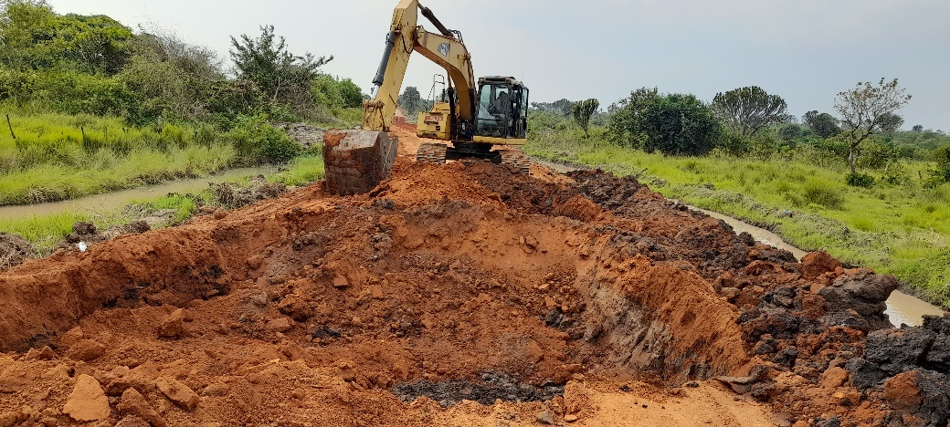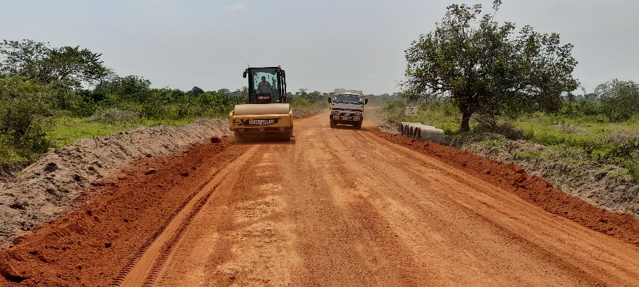

**SWAMPY CONDITIONS**

**DURING CLEARANCE VS FINISHED.SECTION AT (KM 16+450-16+950) ON GOMERO MIGANI.KAGONGI ROAD**

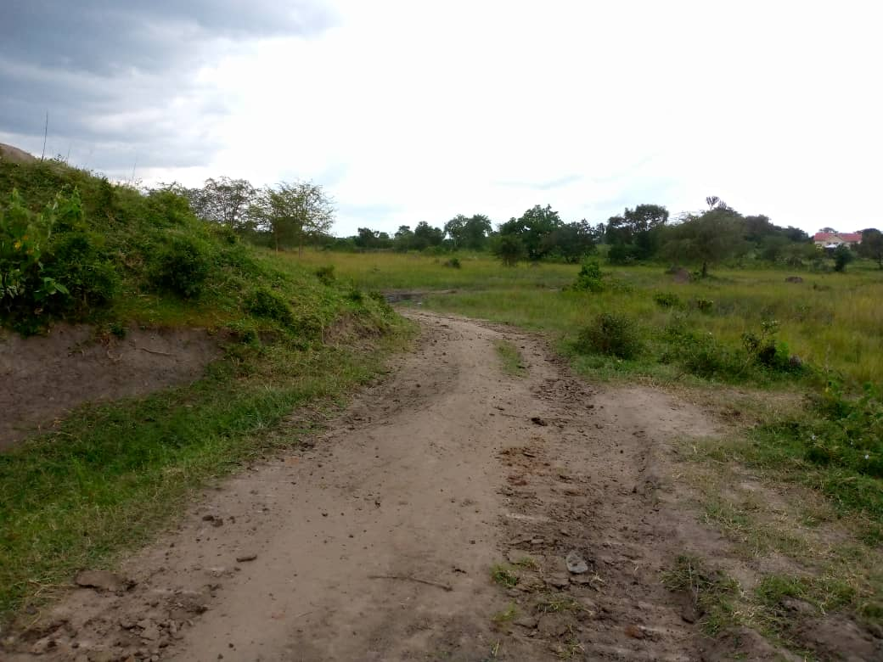 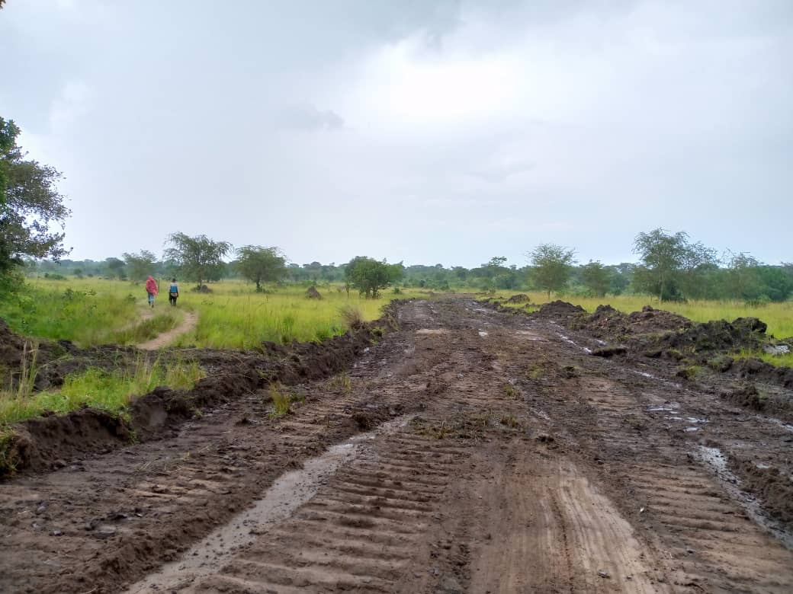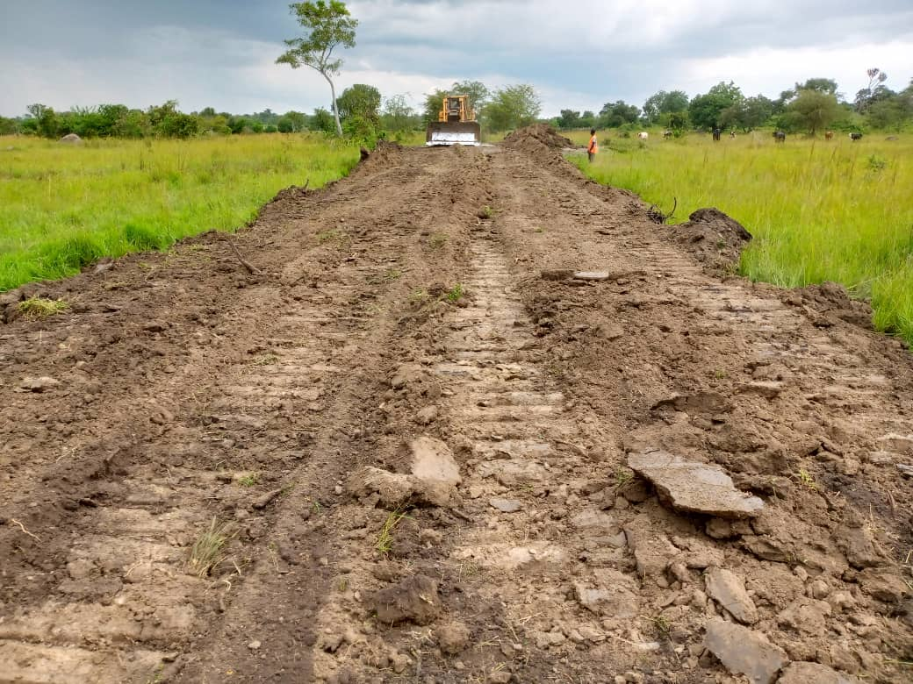 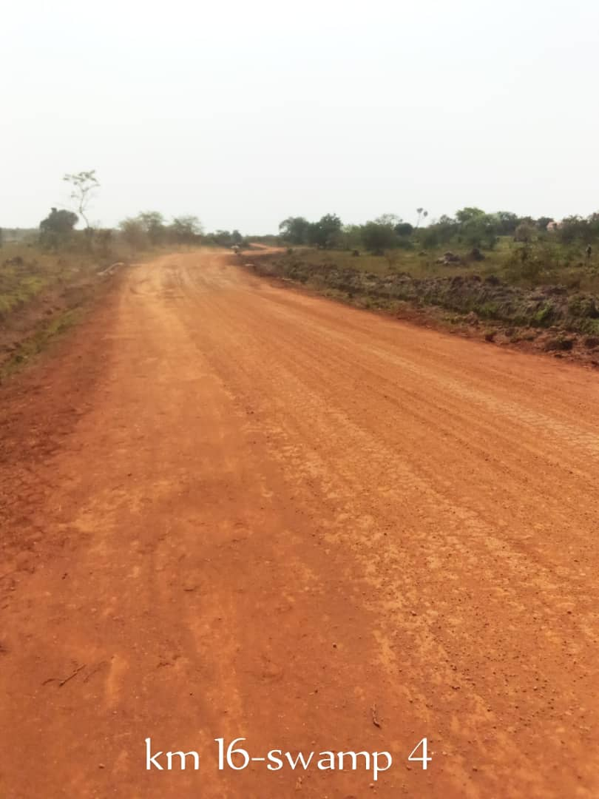

**SWAMPY CONDITIONS**

**DURING CLEARANCE VS FINISHED.SECTION AT KM (19+550-19+700) ON GOMERO MIGANI.KAGONGI ROAD**

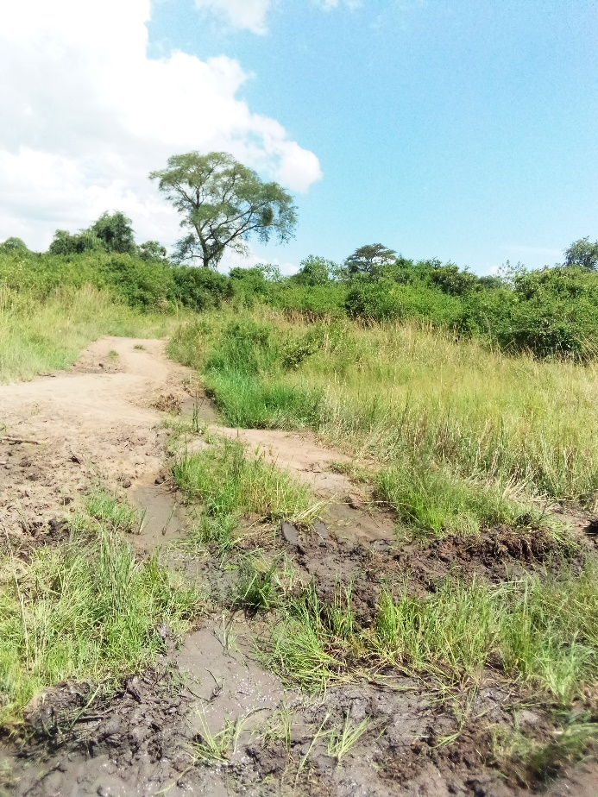 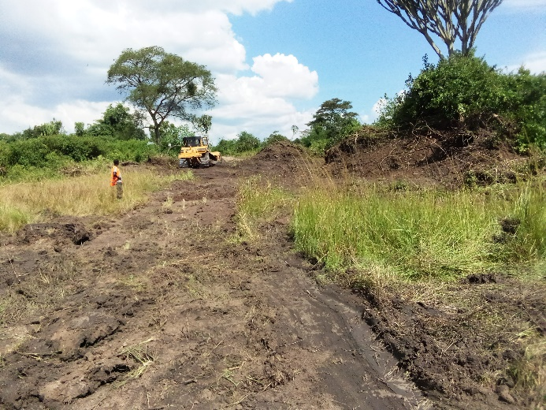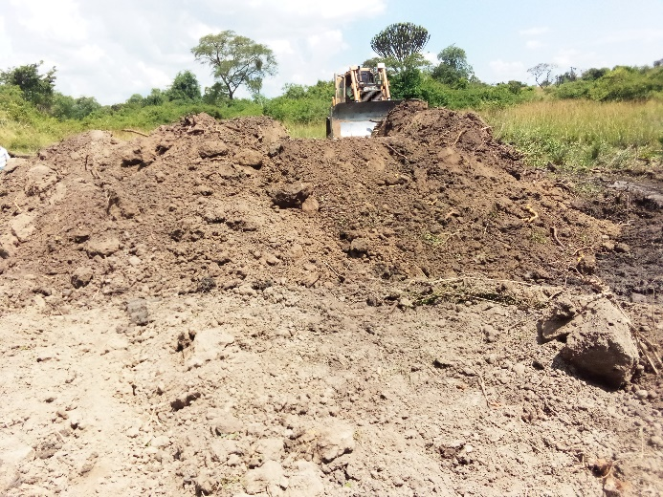

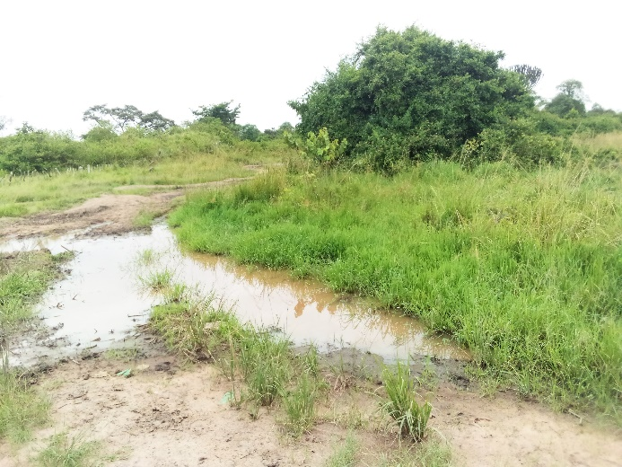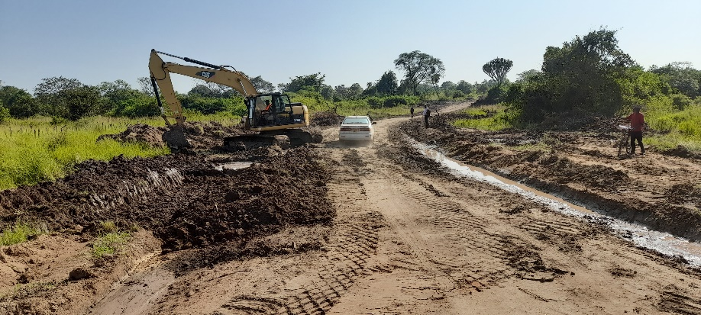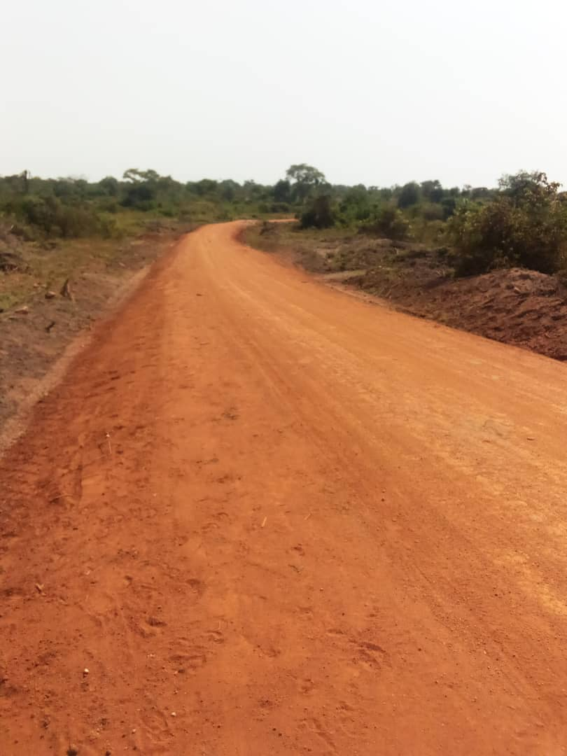

**SWAMPY CONDITIONS**

**DURING CLEARANCE VS FINISHED.SECTION AT (KM 21+600-21+750) ON GOMERO MIGANI.KAGONGI ROAD**

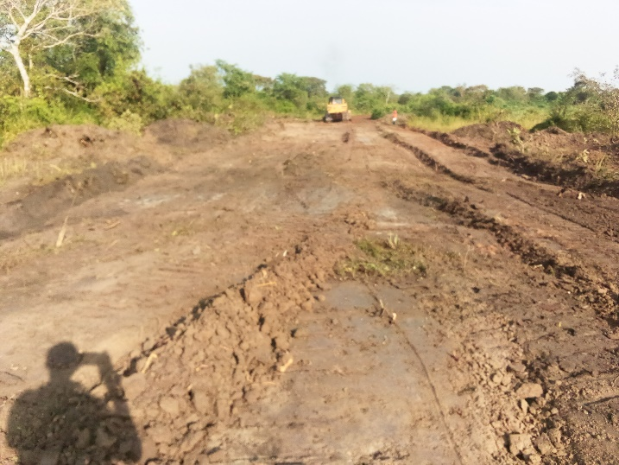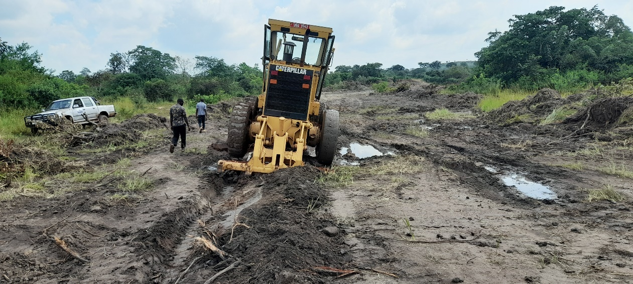

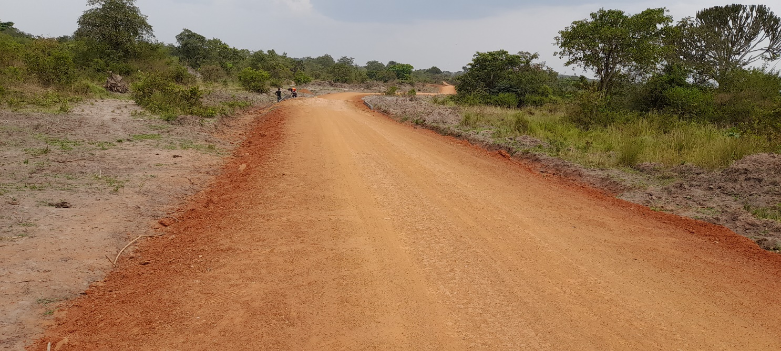

**SWAMPY CONDITIONS**

**DURING CLEARANCE VS FINISHED.SECTION AT (KM 4+000-4+200) ON KAGONGI BUWANA ROAD**

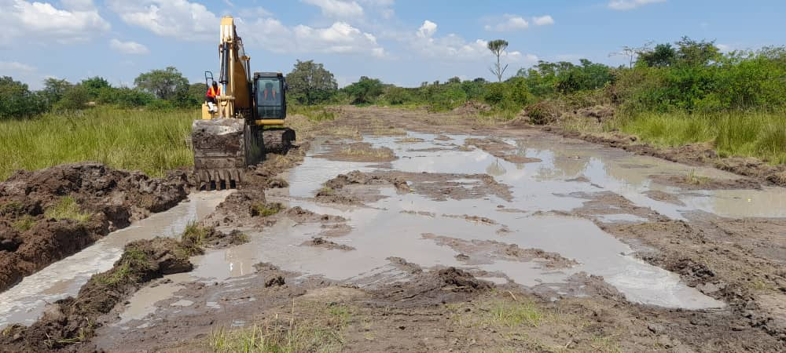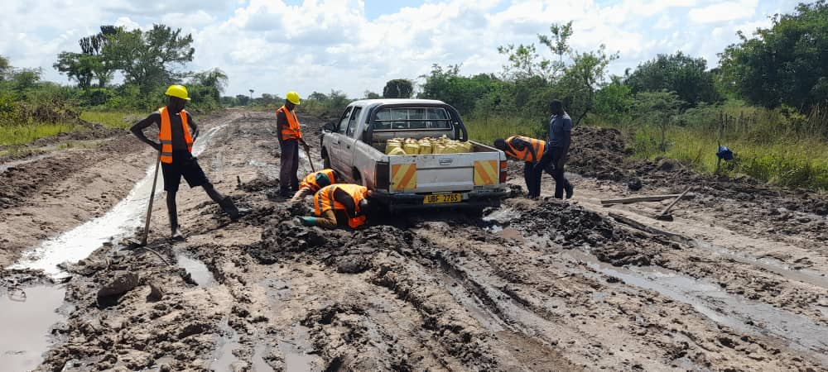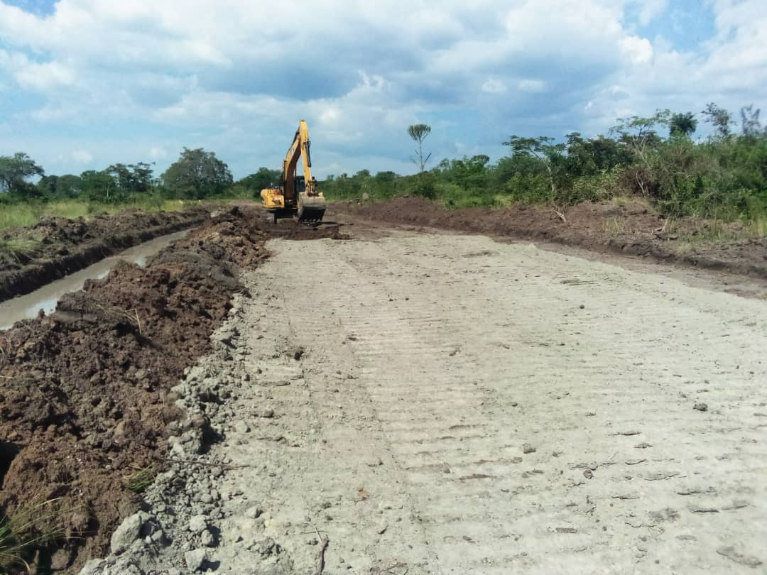 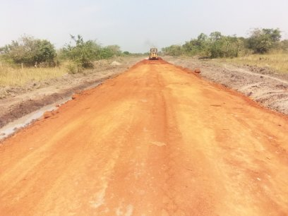.

**SWAMPY CONDITIONS AT (KM 5+100-5+330) ON KAGONGI BUWANA ROAD**

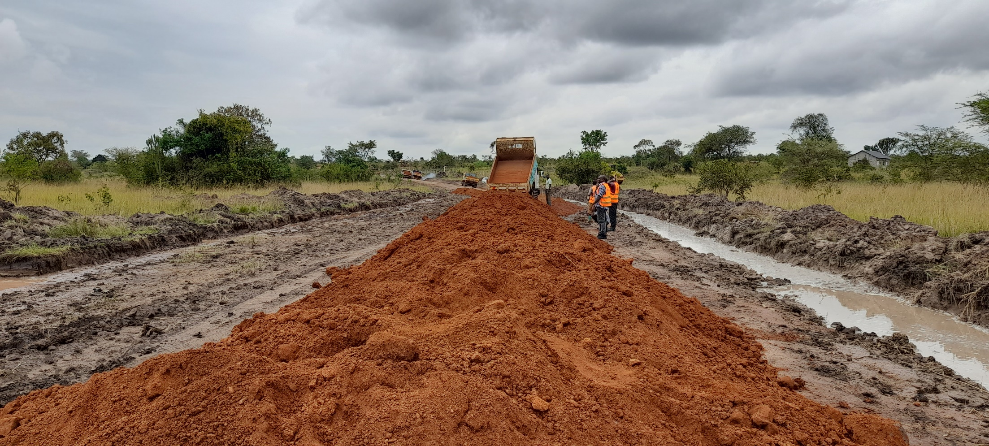

**OTHER NON SWAMPY SECTION**

**KM19+200 KM 19+600**

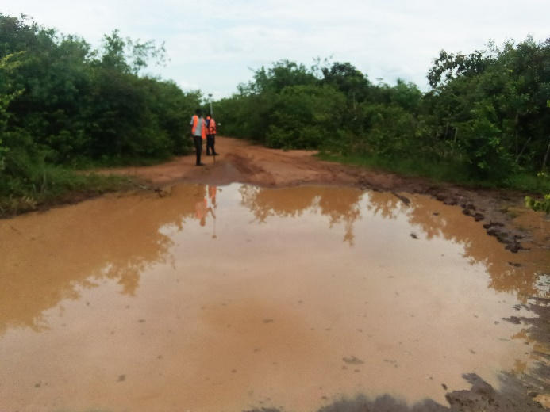 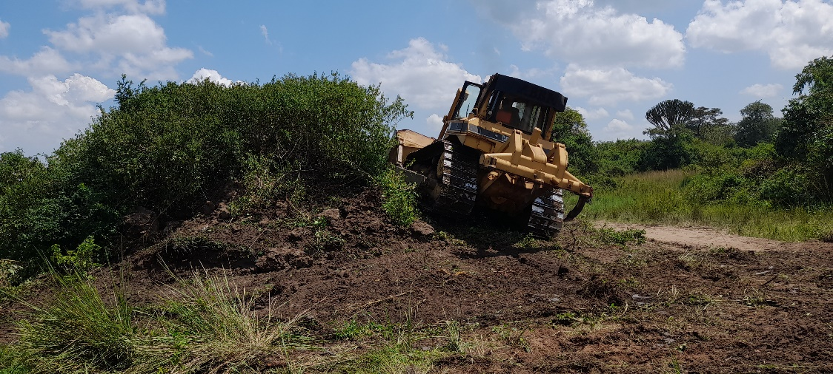

………. 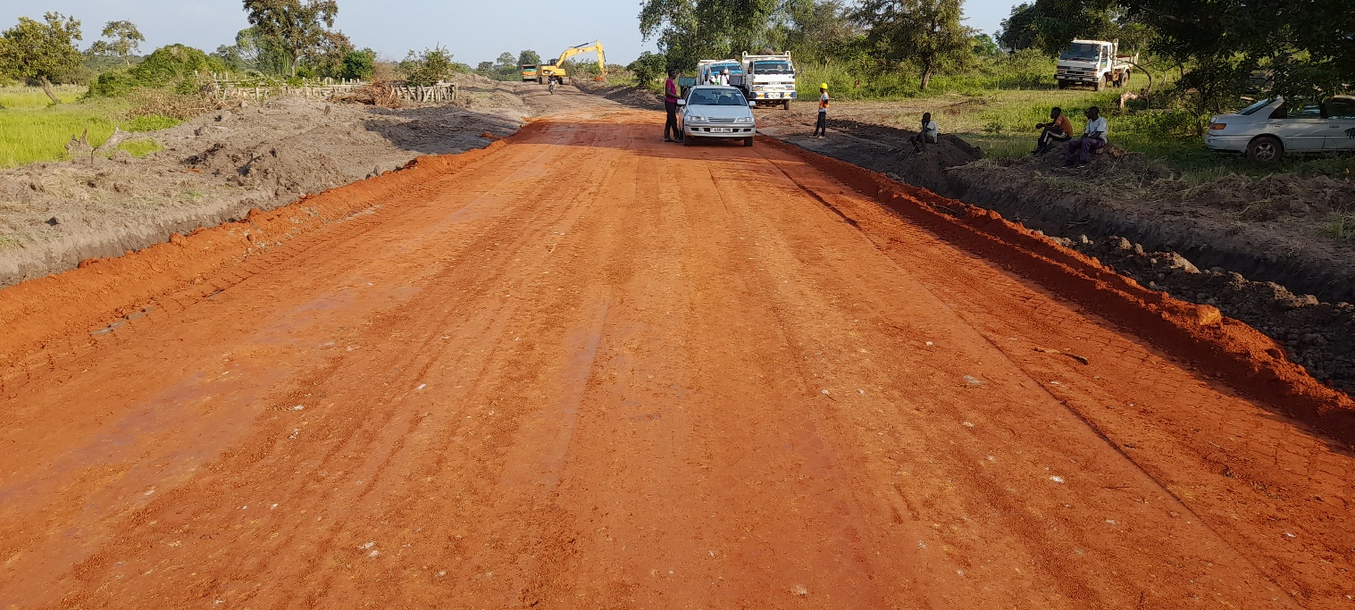

KM(16+450-16+950)